Problem 19（難）
Set partition

Given a set 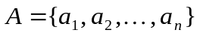 of positive integers, count the number of 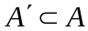 such that
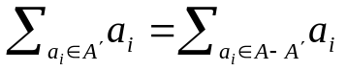
Also generate all such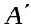.

Input
The input consists of multiple datasets, followed by a line which contains only a single ‘.’ (period). Each dataset is an array of unsigned integers. The array is enclosed by {} and any two adjacent unsigned integers of the array is separated with space.

Output
For each input dataset, print “No such subset” if the input set contains no subsets which meet the criterion. If the input set can be divided into desired subsets, print the number of such subsets first and then print each of those subsets. Each subset is enclosed by {} and printed in one line and any two adjacent positive integers in the subset are separated with space.

Sample Input
{1 2 3 4 5 6 7}
{1 3 5 7 12}
.
Sample Output for the Sample Input
8 subsets.
{1 6 7}
{2 5 7}
{3 4 7}
{1 2 4 7}
{3 5 6}
{1 2 5 6}
{1 3 4 6}
{2 3 4 5}

No such subset

All inputs are from stdin and outputs to stdout.

